const checkBoxList = document.querySelectorAll('.custom-checkbox')

Project 1 part 2 remaining part:

const inputFields = document.querySelectorAll('.goal-input')

const progress_bar = document.querySelector('.progress-bar')

checkBoxList.forEach((checkbox) => {

    checkbox.addEventListener('click', (e) => {

        const allFieldsFilled = [...inputFields].every((input) => {

            return input.value

        })

        if (allFieldsFilled) {

            checkbox.parentElement.classList.toggle('completed')

        } else {

            progress_bar.classList.add('show-error')

        }

    })

})

inputFields.forEach((input)=>{

    input.addEventListener('focus', ()=>{

        console.log(e.target.value);

        progress_bar.classList.remove('show-error')

    })

})

Step1:

1. Add key in the input tag to get access of particular input

First, second, third

1. Create object:

 <input id="first" class="goal-input" type="text" placeholder="Add new goal... " value="">

<input id="second" class="goal-input" type="text" placeholder="Add new goal... "  value="">

 <input id="third" class="goal-input" type="text" placeholder="Add new goal... "  value="">

const obj={

    first:{

            name:'learn js ',

            completed: false

    },

    second:{

            name:' learn node js ',

            completed: false

    },

    third:{

            name:'learn dsa',

            completed: false

    }

}

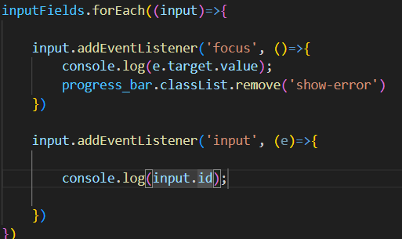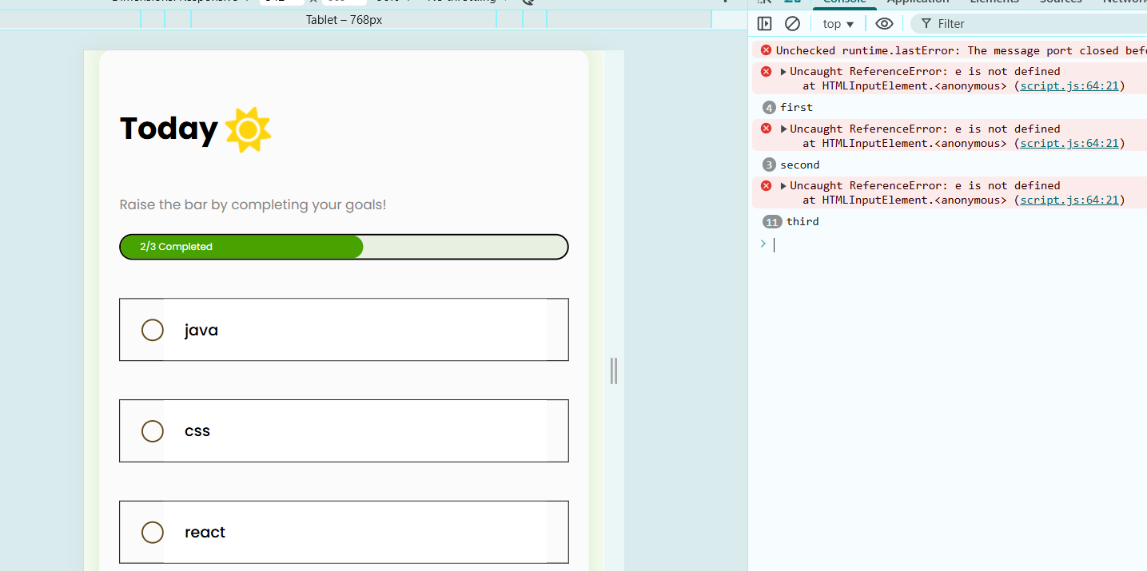  
  
  
  
  
  
  
  
  
  
  
  
  
  
  
  
  
  
  
  
  
check : returning of respective input of respective id’s console.log(input.id);  
  
  
  
  
  
  
  
  
  
step2: Now we are ready to get input data, now we are setting data into object that we have created by creating dynamic key using obj['input.id']

inputFields.forEach((input)=>{

    input.addEventListener('focus', ()=>{

        console.log(e.target.value);

        progress_bar.classList.remove('show-error')

    })

    input.addEventListener('input', (e)=>{

        obj['input.id']=e.target.value

    })

})  
  
we take bracket notation of object to set value and we put input.id so it can get value of current input.id from for each and it respectively assign to that like we already give first , second , third id name in input so it get by input.id and we have alredy make object having key object first, sec , third

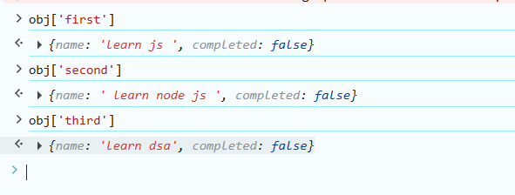  
  
  
  
  
  
  
  
  
  
  
  
  
  
  
  
  
  
  
step 3: setting value in local storage :

obj['input.id']=e.target.value // object value set

localStorage.setItem("objectKey", JSON.stringify(obj)) // object send to LS

inputFields.forEach((input)=>{

    input.addEventListener('focus', ()=>{

        console.log(e.target.value);

        progress_bar.classList.remove('show-error')

    })

    input.addEventListener('input', (e)=>{

        obj[input.id]={

            name:input.value,

            completed:false

        }

        localStorage.setItem("objectKey", JSON.stringify(obj))

    })

})

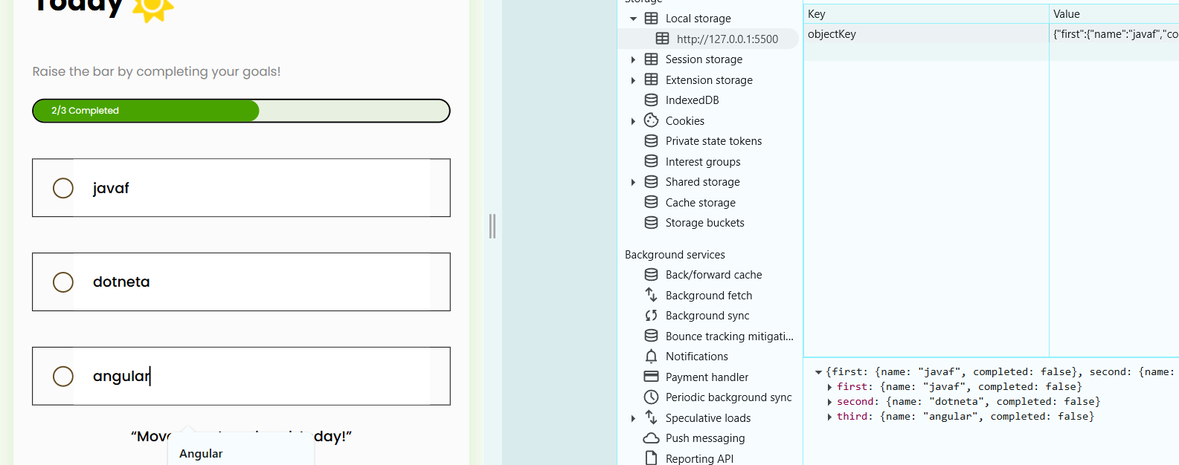

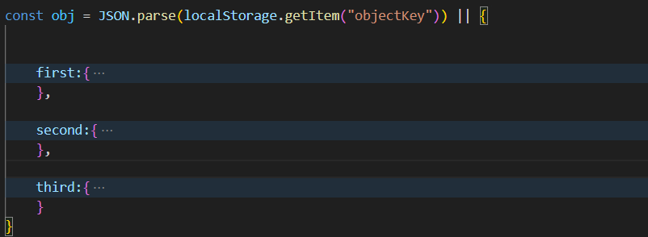Step4: Retrieving val if available   
  
So when we pass all object and then after reload, we have got info if already object is there so it will get from LS we know step is   
  
  
  
  
  
  
  
  
  
  
  
  
  
  
  
  
  
  
  
  
  
  
  
  
  
  
  
  
  
  
  
  
  
  
  
  
  
Step5: आत्ता पर्यन्त आपण object set केला , object ला local storage मध्ये टाकला आणि Value save झालेला value ls मधून acces केले आत्ता ते ui वर कसं दाखवईचे ते पाहू   
